IHE Work Item Proposal (Detailed)

# Proposed Work Item: CDA Document Summary Section

Proposal Editor: Emma Jones, George Dixon, Daniel Venton (Allscripts)

Work item Editor: Emma Jones, George Dixon, Daniel Venton (Allscripts)

Date: November 6, 2017

Version: 1.0

Domain: PCC

# Summary

Providing a concise summary of a document based on specific user expectations can be time saving for a provider. It can also reflect what the patient need to see so that the large amount of information in the CDA document is provided but at the same time not become overwhelming.

Depending on use case, a Summary Section can be added to a document, summarizing pertinent information populated by some of the data in the various sections to create a composite, single Summary section.

A summary section can also be used for the author of the document to describe pertinent information about the document

An example of how content may be represented in a CDA document with a Summary Section:

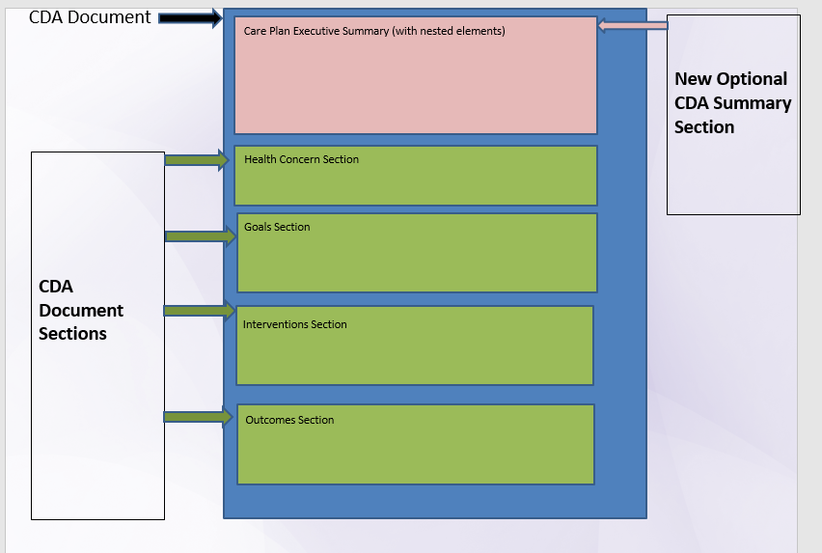

# The Problem

<Summarize the integration problem. What doesn’t work, or what needs to work?>

Current CDA content profiles do not capture specific information needed to be communicated to the reader (e.g. provider and/or patient) in a concise way that will summarize information about the document content. Summary information shared today, is typically a summary of the entire clinical history that can be enormous and often not very useful. Providing the entire clinical history can be overwhelming and lead to complications related to information overload. This makes also makes it difficult to identify pertinent information in an efficient way. Some CDA documents contain elements with linkages to other elements that is often not represented in a way that effectively portrays the clinical picture.

<Describe the Value Statement: What is the underlying cost incurred by the problem and what is to be gained by solving it? If possible provide quantifiable costs, or data to demonstrate the scale of the problem.>

Providers and patients can benefit from a summary of relevant information that can be viewed as part of the document while at the same time providing the opportunity to view the entire document when needed.

# Key Use Case

<Describe a short use case scenario from the user perspective. The use case should demonstrate the integration/workflow problem. Feel free to add a second use case scenario demonstrating how it “should” work. Try to indicate the people/systems, the tasks they are doing, the information they need, and where the information should come from.>

Use Case 1

There is an emerging requirement for a new CDA section that might become required in many, if not most, clinical circumstances. Physicians working in several separate coordination endeavors are calling for a ***Synopsis section***. This would be unstructured and would be a place for the author to explain the purpose of the document, what should be done, what portions or items in the document should get special attention, etc. Basically, they want the brief cover note that they write to the next provider. Thus far, those proposing this new section strongly resist any suggestions to add any structure to the synopsis.

Source: Thom Kuhns

<http://wiki.hl7.org/index.php?title=Consolidated_CDA_July_2012_Suggested_Enhancements>

Use Case 2

Hybrid Summary Section - CDA document templates implementation guides can be written as open templates. Implementers are creating documents with many added sections to satisfy multiple uses. For example, a CCD document can contain Discharge Summary document sections. This use case supports adding a Hybrid Summary Section to this kind of document to show the relevant “Discharge” section data– e.g. discharge diagnosis, discharge medications, discharge instructions, etc., components while at the same time providing the ability for the user to traverse the entire document, containing both the CCD sections and the Discharge Summary sections as needed.

Use Case 3

Summary per Encounter – A CDA document can contain a huge amount of content that can span a wide range of time. Providing the ability for a user to view content that was changed during a specified encounter date – such as the most recent encounter or medications that were changed during this encounter or during the most recent encounter. This can assist the user in quickly gaining insight into care that was recently provided to the patient. This can be done while, at the same time, providing the ability for the user to view the entire document.

Use Case 4

Active/Planned Summary – A CDA document can contain multiple sections with data elements that are planned. For example, the following sections can contain planned and/or active medications - medication section, plan of treatment section, medications administered section, intervention section, admission medication section, discharged medication section, procedure section. Providing a means of viewing a list of all active/planned medications in one section without having to traverse across the document if all of these sections are in the same document would be very helpful and time-saving for the user. The user is still able to view the entire document if needed.

Use Case 5

Care Plan Nesting - Consolidated CDA Care Plan document provides the ability to link entry templates together to tell the care planning story. Providing an easy view of how care plan components are linked and nested, without forcing the traversing across various sections, will be very helpful to the user. Please note that the user is still able to view the entire document if needed.

# Standards & Systems

<List existing systems that are/could be involved in the problem/solution.>

<If known, list specific components of standards which might be relevant to the solution.>

Standards

* CDA R2
* IHE PCC Medical Document
* Consolidated CDA 2.1

Systems

* EHR
* PHR
* Patient Portal
* HIE

# Technical Approach

<This section can be very short. Feel free to include as much or as little detail as you like. The Technical Committee will flesh it out when doing the effort estimation.>

<Outline how the standards could be used and refined to solve the problems in the Use Cases. The Technical Committee will be responsible for the full design and may choose to take a different approach, but a sample design is a good indication of feasibility.>

This profile will define CDA concepts that can be used to create the content for the applicable use case based sections. For example, the Care Plan Nesting use case will generate content for the Care Plan Summary section based on the data found in the health concern, goals, interventions and outcomes sections in the containing document.

New actors

<List possible new actors>

* No new actors

Existing actors

<Indicate what existing actors might be affected by the profile.>

* Content Creator
* Content Consumer

New Transactions (standards used)

<Describe possible new transactions (indicating what standards would likely be used for each. Transaction diagrams are very helpful here. Feel free to go into as much detail as seems useful.>

* No new transactions

<Point out any key issues or design problems. This will be helpful for estimating the amount of work.>

<If a phased approach would make sense indicate some logical phases. This may be because standards are evolving, because the problem is too big to solve at once, or because there are unknowns that won’t be resolved soon.>

<Indicate how existing / /transactions might need to be modified.>

Impact on existing integration profiles

<Indicate how existing profiles might need to be modified.>

* The applicable summary section can be added CDA document ‘open’ templates

New integration profiles needed

<Indicate how existing profiles might need to be modified.>

Breakdown of tasks that need to be accomplished

<A list of tasks would be helpful for the technical committee who will have to estimate the effort required to design, review and implement the profile.>

# Risks

<List technical or political risks that will need to be considered to successfully field the profile.>

C-CDA 2.1 concepts may need to be US National Extension

# Open Issues

# Effort Estimates